Alberth Matos
21 April 2026
Lab 6 report
CYOP 300 - BUILDING SECURE WEB APPLICATIONS

Executive Summary
Attached is my submission for Lab 6. As my Flask-driven site, I chose to implement a simple blog web application. The application presents static pages as well as blog entries rendered from plain text markdown files.
Each page contains a header section with links to the main blog page, an About page, a Contacts page, a Photography page, and a link labeled “Purposefully broken link” that points to a non-existent page, used to demonstrate the custom 404 error page. Additionally, the footer of each page contains a link to four external sites, my GitHub, LinkedIn, Mastodon sites, as well as a link to my PGP key, displayed as an ordered list. The footer also contains the time at which the page was generated by Flask.
The application loads individual blog entries from the posts directory. Each blog entry must have a .md extension, and its markdown frontmatter must include a date and a title. The file extension, in combination with the two frontmatter fields allow the program to identify that the file is a valid blog entry.
The photography page contains examples of H1, H2, and H3 html tags, and displays images as an unordered list. Each image was chosen from my photography collection, and link to my Flickr page. The page source contains html comments containing the title name of each picture.
A CSS style sheet is served via the flask application, applying a common look-and-feel to all of the site pages.

Testing

Test Case Table
Test Cases | Description | Expected Output | Actual Output | Pass/Fail
Test Case 1 | Posts directory missing | Main page displays a single entry, named ‘Habemus nulla posta. Quo vadis?’ | Main page displays a single entry, named ‘Habemus nulla posta. Quo vadis?’ | Pass
Test Case 2 | Posts directory exists, but no .md are available | Main page displays a single entry, named ‘Habemus nulla posta. Quo vadis?’ | Main page displays a single entry, named ‘Habemus nulla posta. Quo vadis?’ | Pass
Test Case 3 | Posts directory exists, .md file is found, but file does not contain required fields (Date and Title) | Main page displays a single entry, named ‘Habemus nulla posta. Quo vadis?’ | Main page displays a single entry, named ‘Habemus nulla posta. Quo vadis?’ | Pass
Test Case 4 | Multiple valid posts exist | Main page displays each post in index | Main page displays each post in index | Pass
Test Case 5 | Display post | Post displays | Post displays | Pass
Test Case 6 | Click on ‘Main’ link in page header | Main page displays each post in index | Main page displays each post in index | Pass
Test Case 7 | Click on ‘About’ link in page header | About page is displayed | About page is displayed | Pass
Test Case 8 | Click on ‘Contact’ link in page header | Contact page is displayed | Contact page is displayed | Pass
Test Case 9 | Click on ‘Photography’ link in page header | Photography page is displayed | Photography page is displayed | Pass
Test Case 10 | Click on ‘Purposefully broken link’ in the header | Note: This link points to a page that does not exist to show http 404 error handling.  A 404 error page should display. | A 404 error page is displayed | Pass
Test Case 11 | Click on ‘github’ link in page footer | A github page should display | A github page is displayed | Pass
Test Case 12 | Click on ‘LinkedIn’ link in page footer | A LinkedIn page should display | A LinkedIn page is displayed | Pass
Test Case 13 | Click on ‘mastodon’ link in page footer | A Mastodon.social page should display | A Mastodon.social page is displayed | Pass
Test Case 14 | Click on ‘PGP Key’ link in page footer | A file named hah4j8h73y4qhdxez8g3dsj9rdibnhqi will download | A file named hah4j8h73y4qhdxez8g3dsj9rdibnhqi is downloaded | Pass

Test Case Screenshots

Test Case 1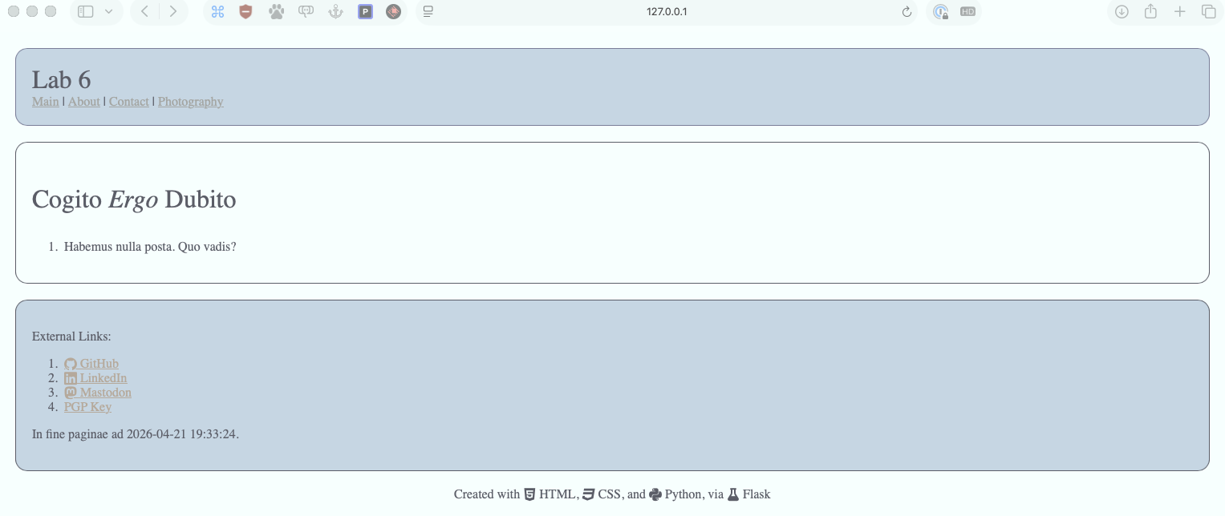

Test Case 2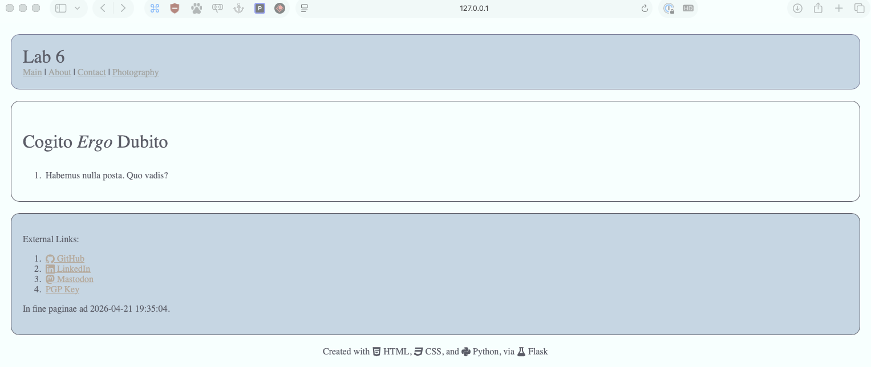

Test Case 3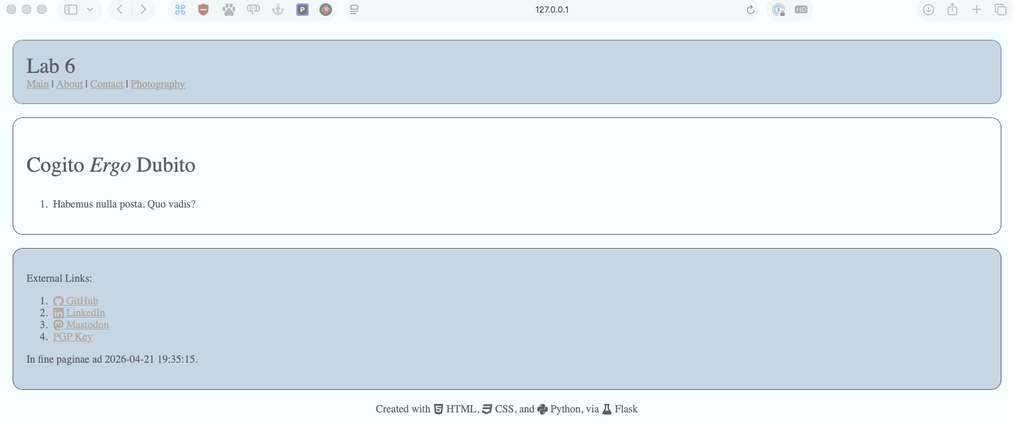

Test Case 4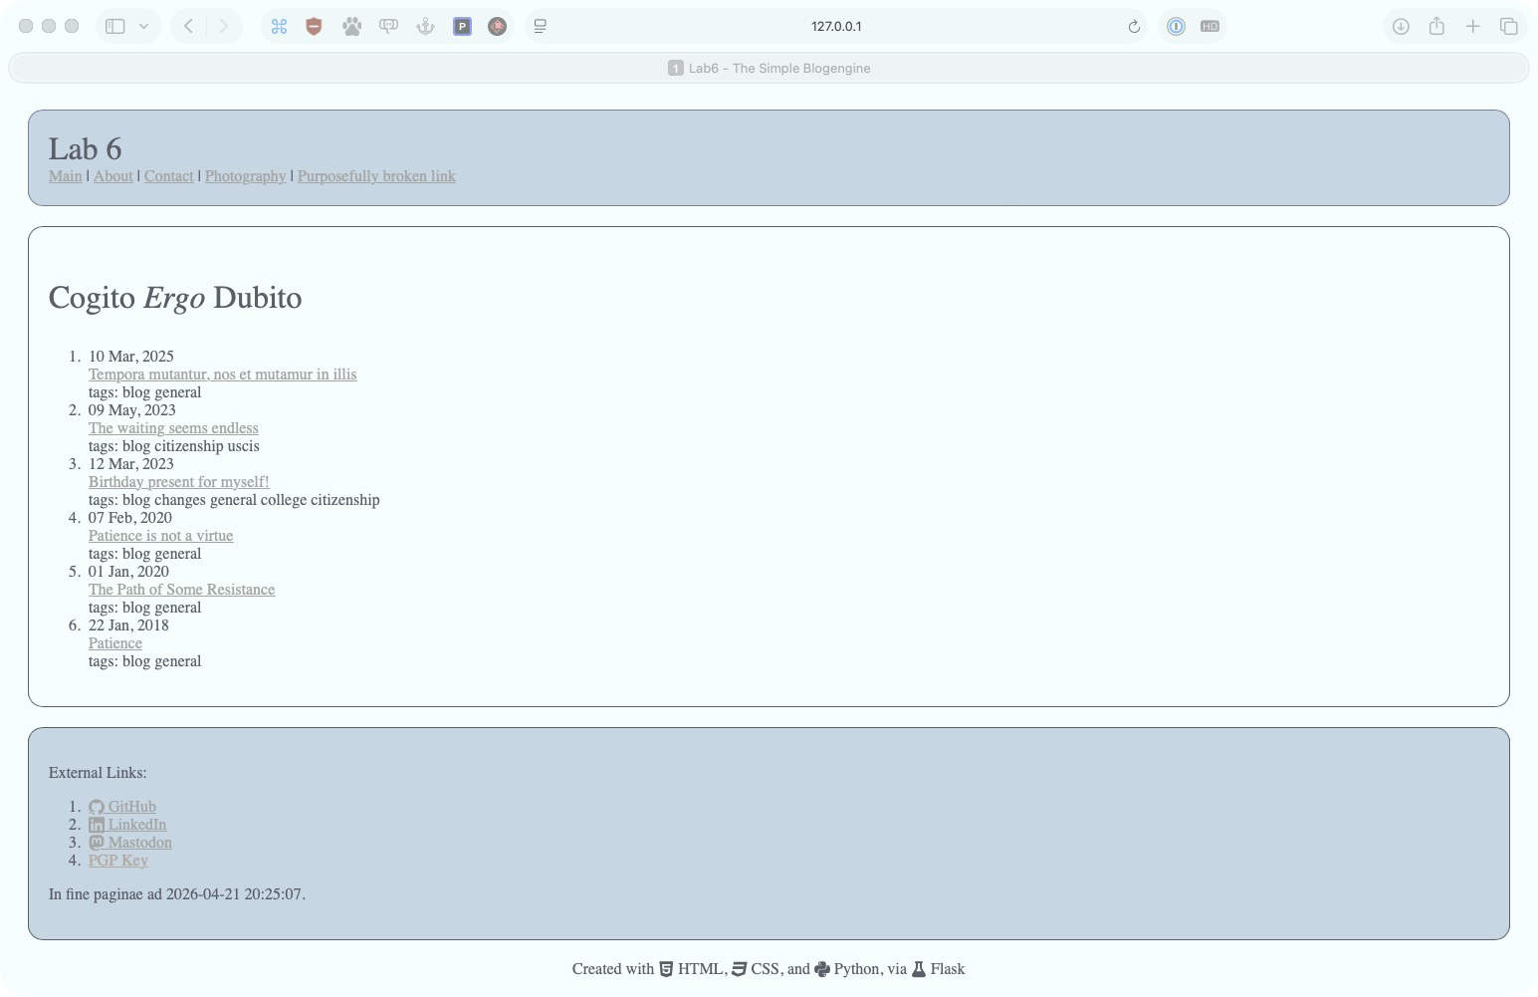

Test Case 5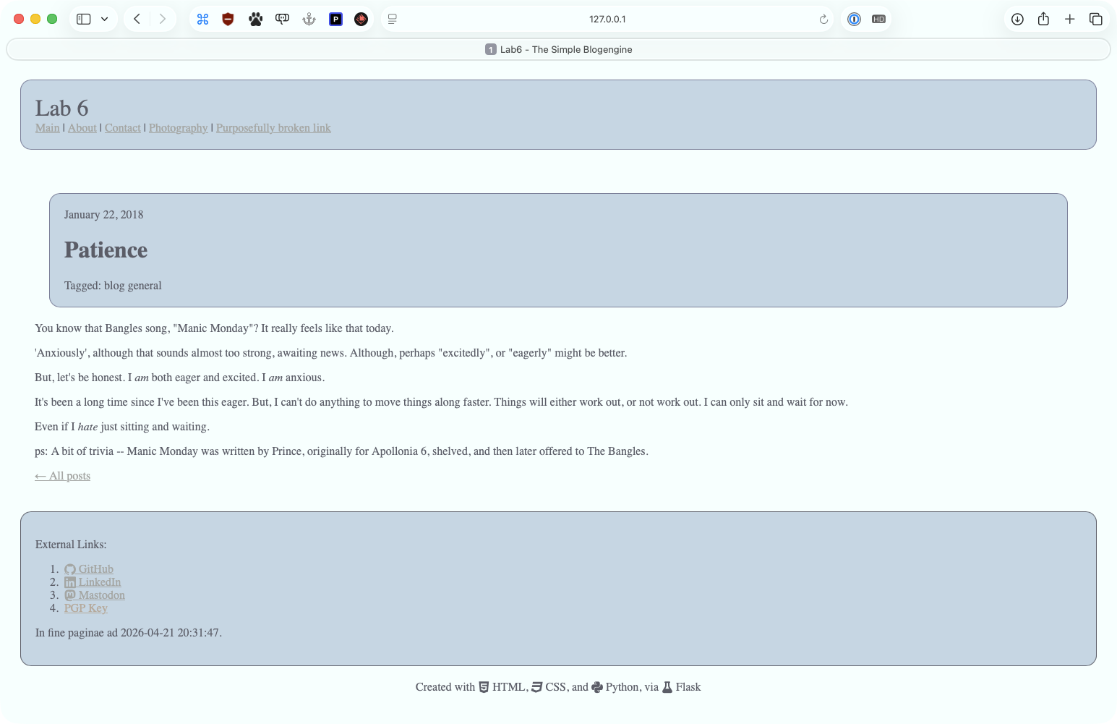

Test Case 6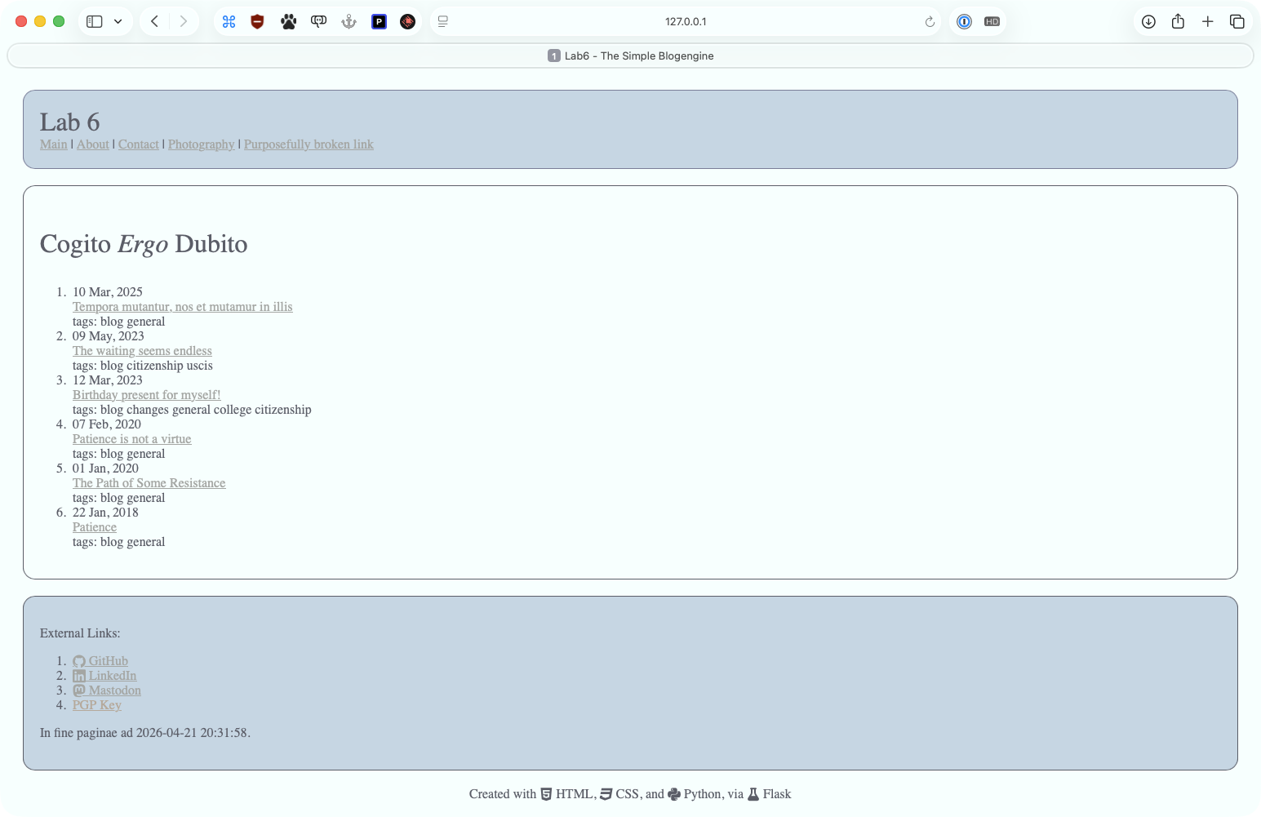

Test Case 7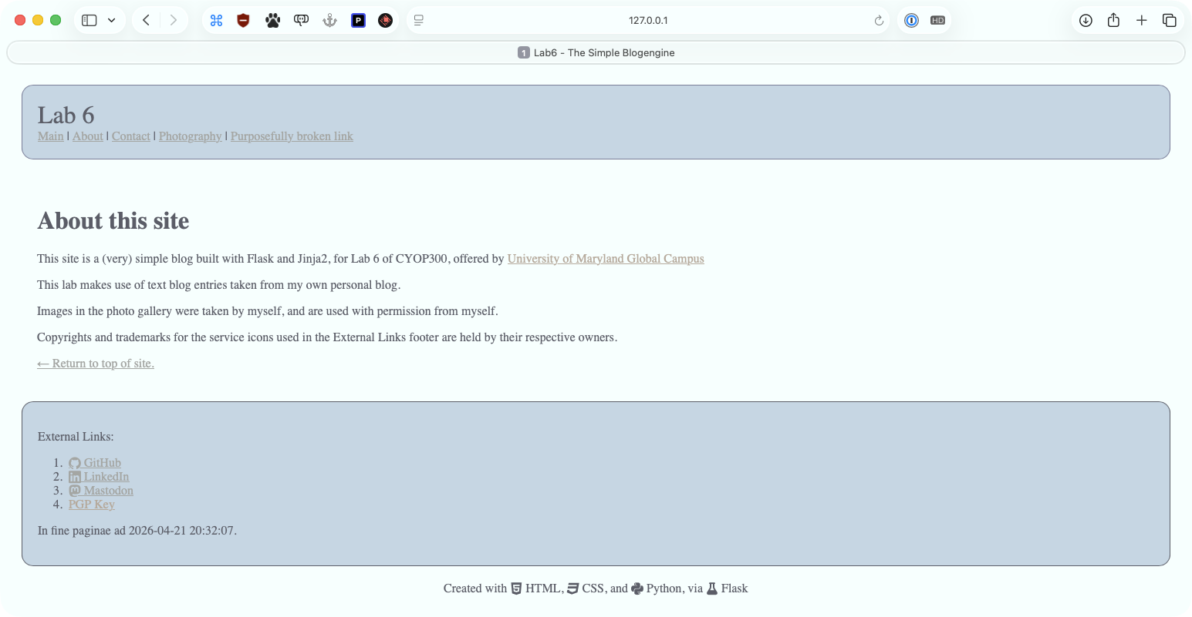

Test Case 8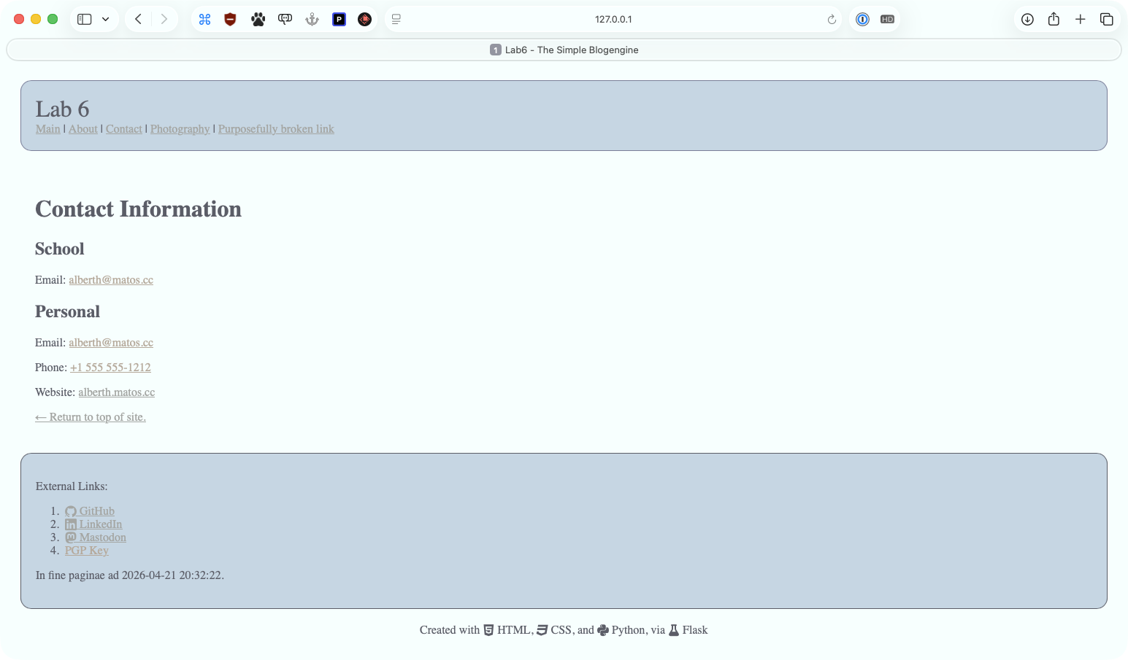

Test Case 9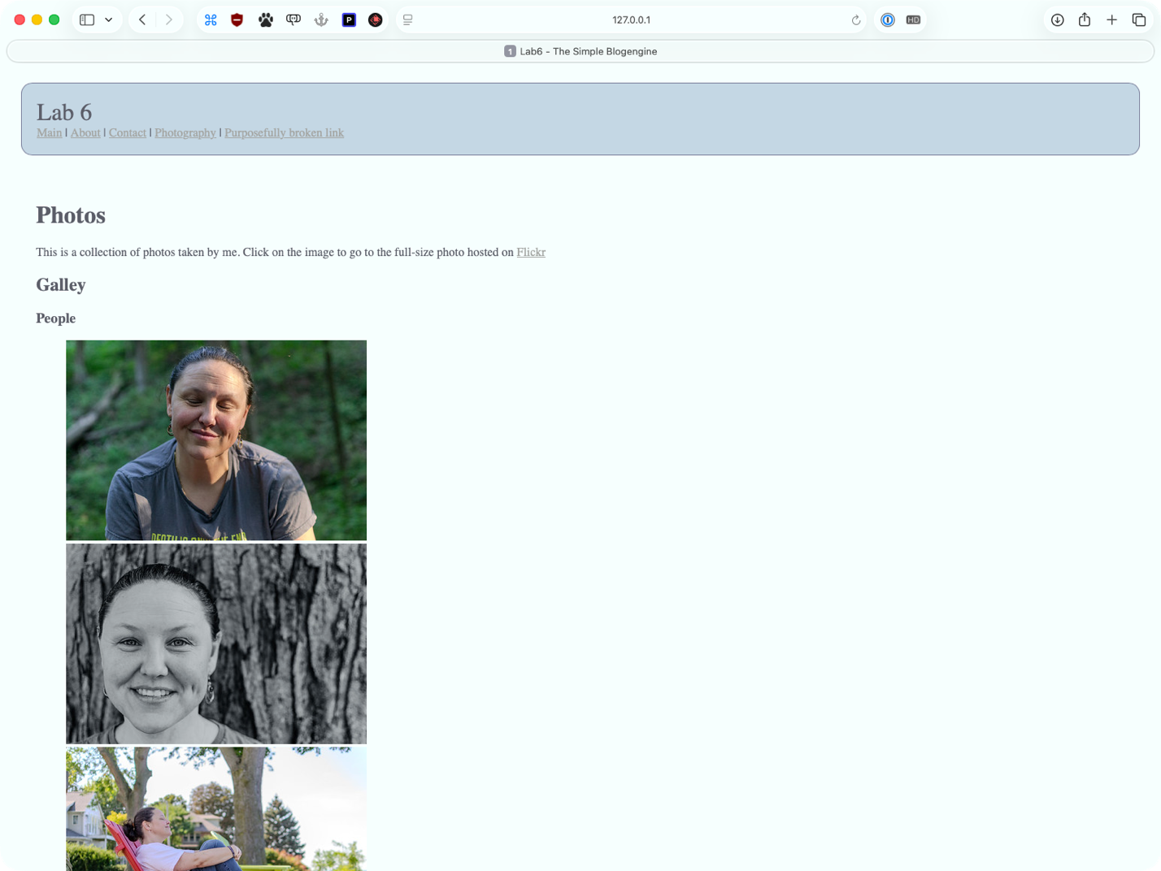

Test Case 10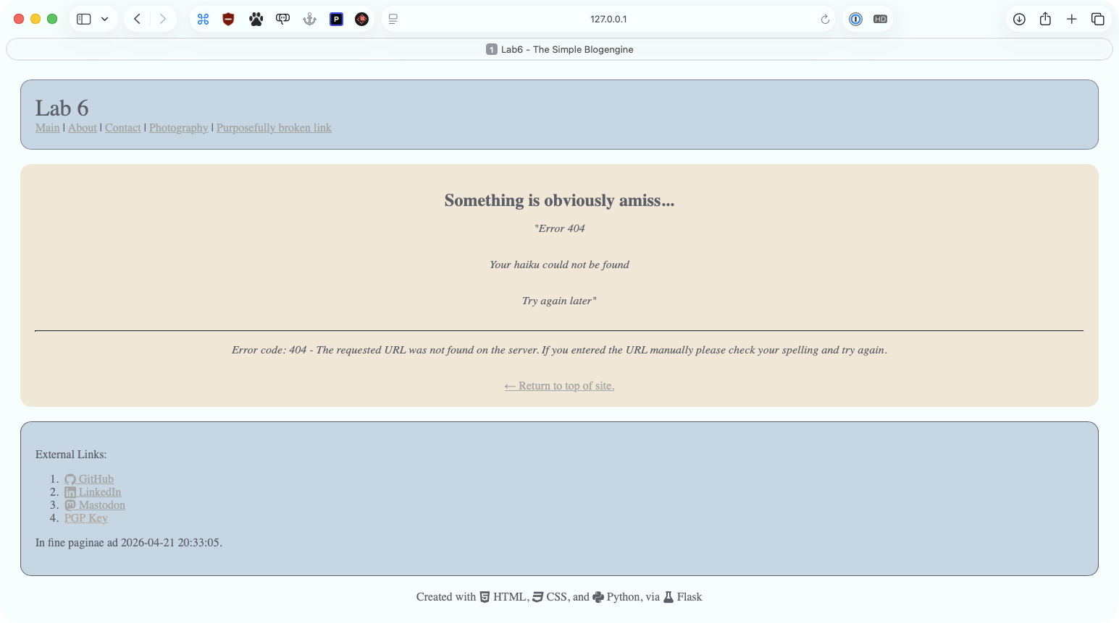

Test Case 11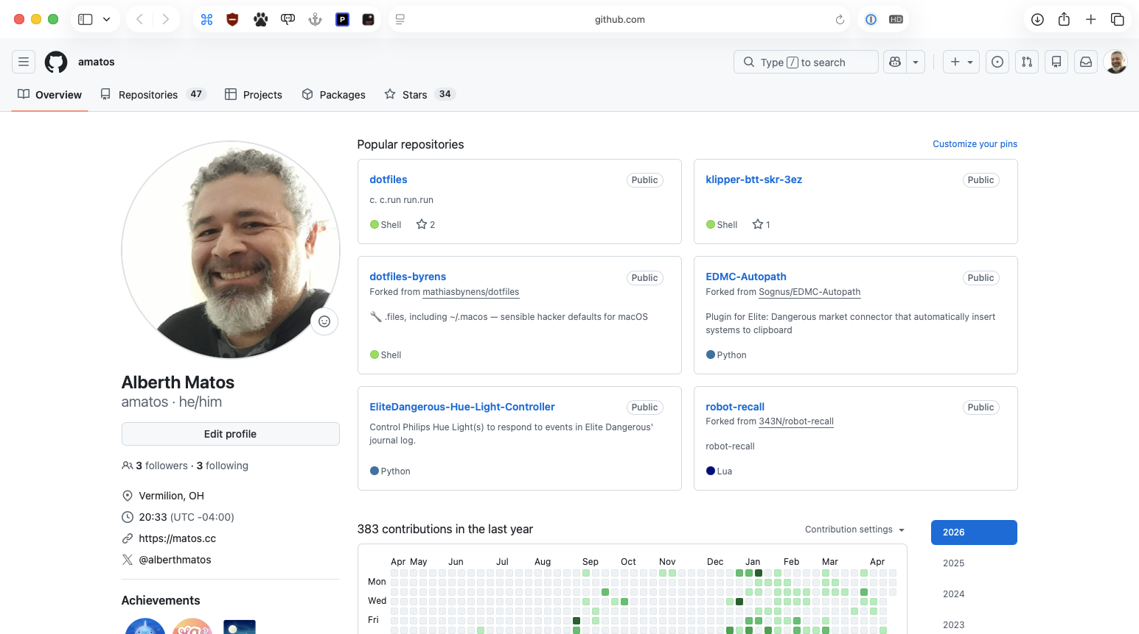

Test Case 12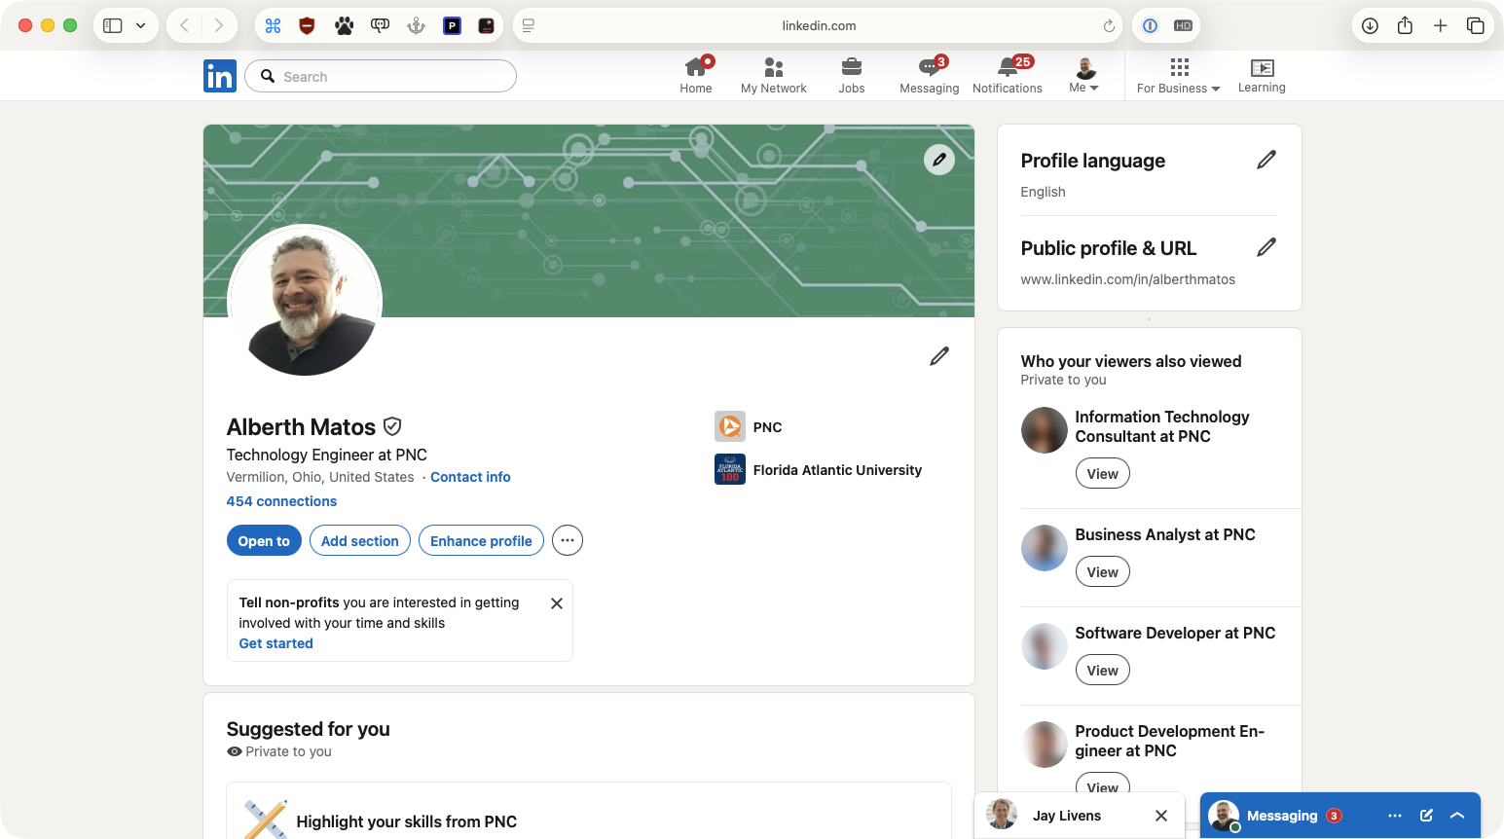

Test Case 13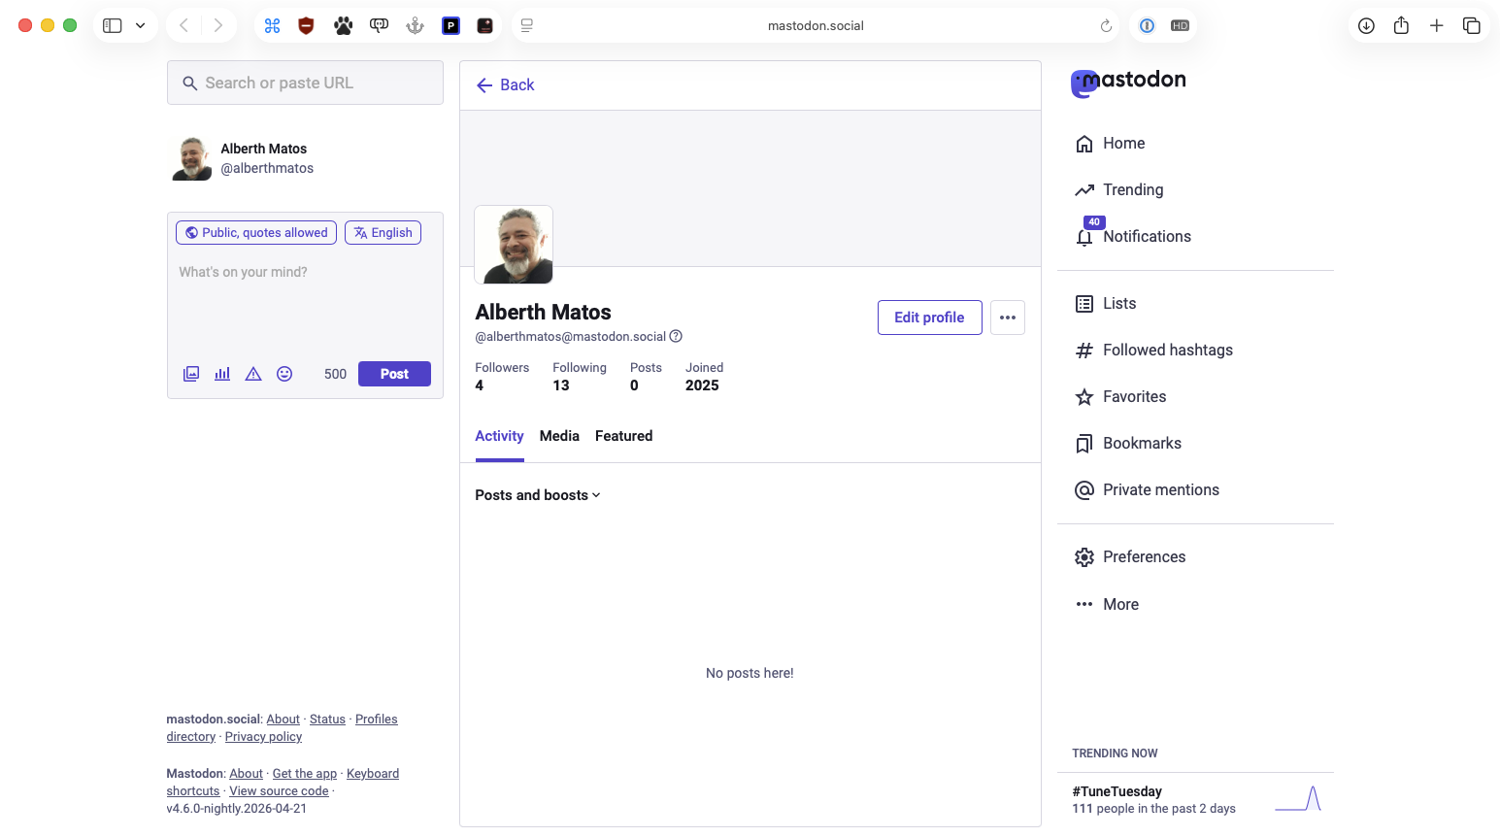

Test Case 14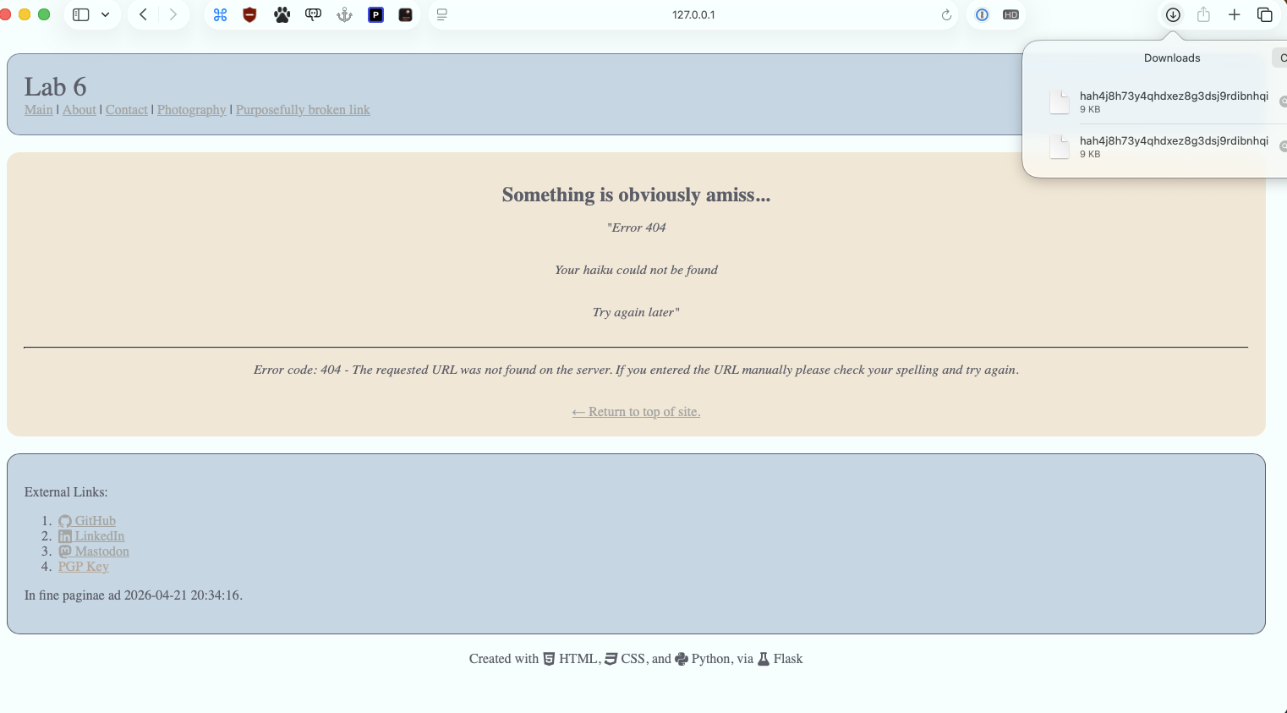

Pylint Results
λ pylint *.py
-------------------------------------------------------------------
Your code has been rated at 10.00/10

